**Voting System For General Elections**

A

Mini Project Report submitted to Savitribai Phule Pune University, at Pune



In partial Fulfillment for the awards of Degree of Engineering in Computer Engineering

**Submitted by**

**Group no:A1-4**

**Mr.Himanshu Gaikwad Exam Seat No. S190084254**

**Mr.Prashant Shejwal Exam Seat No.S190084346**

**Mr.Ashwin Patil Exam Seat No. S190084308**

**Mr.Abhishek Ambekar Exam Seat No. S190084206**

**Under the Guidance of**

**Mrs.Dhanashree Phalke**



**May 2023-24**

**Department of Computer Engineering**

**D.Y.Patil College of Engineering,**

**At Akurdi, Pune-44.**

**D. Y. Patil College of Engineering,At** **Akurdi, Pune-44**

**Department of Computer Engineering**

(2023-2024)

**Certificate**



This is to certify that,

Group no: **A1-4**

Himanshu Gaikwad, Exam seat no:S190084254

Prashant Shejwal, Exam seat no: S190084346

Ashwin Patil, Exam seat no:S190084308

Abhishek Ambekar, Exam seat no:S190084206

have successfully completed the Mini project entitled “**Voting System For General Elections**” my guidance has contibuted to meeting the partial requirements for the SecondYear of Engineering in Computer Engineering studies under the Savitribai Phule Pune University during the academic year 2023-2024

**Date : ……………….**

**Place:……………….**

**……………………………….**

**Mrs. Dhanashree Phalke**

**Project Guide**

**Dr. Mrs. M. A. Potey**

**HoD Computer Enginnering**

**Acknowledgements**

We express our heartfelt gratitude to all the individuals who have provided us with their invaluable guidance and support, illuminating our path throughout our project journey. We deeply appreciate the efforts of these knowledgeable mentors who generously shared their expertise and assistance, contributing to the success of our project.

We are honored to extend our sincere appreciation to **Dr. Mrs. P. Malathi ,** Principal of DYPCOE Akurdi,Pune-44 for her insightful feedback and gracious permission to proceed with this project. We are truly thankful to **Dr. Mrs. M. A. Potey,** H.O.D.Computer Engineering Department for their timely advice and invaluable direction.

We extend our heartfelt appreciation to **Mrs. Dhanashree Phalke** for her outstanding guidance and invaluable support in completing this project. We also express our gratitude to all our colleagues for their valuable assistance throughout the project. We are grateful for the collaboration of industry experts and lab technicians who have contributed to the comprehensive coverage of our project.

We are deeply grateful to our parents for their unwavering support in successfully completing our project. Additionally, we extend our thanks to all our friends and individuals who have been directly or indirectly involved in our project journey.

Mr.Himanshu Gaikwad

Mr.Prashant Shejwal

Mr.Ashwin Patil

Mr.Abhishek Ambekar

***Abstract***

The Online Voting System is a web-based application developed to facilitate electronic voting. The platform is meticulously crafted to offer a dependable and secure environment for voters to cast their votes using the internet. The project was developed using HTML, CSS, JavaScript, PHP, and MySQL technologies. The system has a login page, registration page, and dashboard page for voters to access.

The login page is the first page that users see when they access the system. Registered users can log in to the system using their mobile number, password, and role. The role is used to distinguish between voters and groups or candidates.

The registration page is used to register new users in the system. New users are required to provide their name, mobile number, password, confirm password, address, image, and role. The system validates the mobile number to ensure that no user can register twice using the same mobile number.

The dashboard page is where the voters can view their profile information like name, image, voting status, and mobile number on the left side of the page. On the right side of the page, there will be a list of groups or candidates whom they can cast their votes

**Keywords:**

1. Voting system
2. General election
3. Face verification
4. Authentication
5. Facial recognition

**Contents**

**Abstract 4**

**Table of Contents 5**

**Abbreviations 6**

**Figures 7**

**Tables 8**

**1** **Introduction 9**

1.1 Overview

1.2 Aim/Motivation

1.3 Objective

1.4 Organization of Report

**2** **Literature Survey 11**

**3 Problem Statement 12**

**4. Software Requirements Specification 13**

4.1 Hardware Requirements

4.2 Software Requirements

**5. System Design 14**

5.1 Project Block Diagram

5.2 GUI of Working System

**6. Conclusion and Future Scope 20**

**References 21**

**List of Abbreviations**

1. GUI : Graphical User Interface
2. DBMS : Database Management System
3. SQL : Structured Query Language
4. API : Application Programming Interface
5. UI : User Interface
6. SQLi : SQL Injection
7. API : Application Programming Interface

**Figures**

Figure 1 **Flow Chart 14**

Firure 2 **Data Flow Diagram** 15

Figure 3 **DataBase Schema 16**

**List of Tables**

Table 1: **Literature Survey 11**

**Chapter 1**

**Introduction**

* 1. **Overview**

The implementation of an efficient and secure voting system is essential for ensuring the integrity and fairness of general elections. In response to this need, our project focused on the creation and advancement of a robust voting system customized to suit for general elections. This overview provides a glimpse into the key aspects of our project, including its objectives, scope, methodology, and outcomes.

**1.2 Aim**

Secure Voting System for General Elections: Facial Verification for Enhanced Authentication

**1.3 Motivation**

The motivation behind the development of the Online Voting System is to address the challenges and inefficiencies associated with traditional voting methods. Elections are a fundamental aspect of democratic societies, providing citizens with an opportunity to elect leaders who represent their interests and values. However, the traditional voting process is often plagued with challenges such as long queues, voter intimidation, and logistical problems associated with setting up and managing physical polling stations.

The Online Voting System was developed to provide a convenient, efficient, and accessible way for citizens to participate in the voting process. The system enables registered voters to cast their votes using the internet, thereby eliminating the need for physical travel to the polling stations. The system is intended to offer a secure and trustworthy platform for voters to cast their votes, ensuring that the integrity of the voting process is protected.

The system also saves time and costs associated with hiring and training election officials and setting up physical polling stations. By eliminating the need for physical polling stations, the Online Voting System reduces the risk of voter intimidation and manipulation. Voters have the convenience of casting their votes from their residences or workplaces, reducing the risk of exposure to COVID-19 or other health risks.

The online voting system also promotes transparency and accountability in the voting process. The system ensures that each voter can only vote once, and duplicate voting is not possible. The use of advanced security features in the system ensures that the integrity of the voting process is protected, and the results are transparent and accessible in real-time.

**1.3 Objectives**

1. To provide a secure and reliable platform for citizens to cast their votes remotely using the internet.

2. To eliminate the need for physical travel to polling stations, thereby reducing the risk of voter intimidation and manipulation.

3. To reduce the time and costs associated with traditional voting methods, including the hiring and training of election officials and the setting up of physical polling stations.

4. To ensure that each voter can only vote once, and duplicate voting is not possible.

5. To ensure that the voting process is transparent and accessible in real-time.o.

**1.4 Organization of Report**

The rest of the report is organised at following:

* **1:** Introduction
* **2:** Literature Survey
* **3:** Problem Statement
* **4:** Software Requirement Specifications
* **5:** System Design
* **6:** Conclusin and Future Scope

**Chapter 2**

**Literature Survey**

|  |  |  |  |  |
| --- | --- | --- | --- | --- |
| **Sr.no** | **Name of Paper** | **Name of Author** | **Algorithm Used** | **Future Scope** |
| 1. | “Online Voting System,"  Published in the International Journal of Computer Science and Network Security. [1] | B. Shrestha and S. Khanal, pp. 105-112, 2016 | Encryption algorithms for secure transmission of votes, algorithms for vote tallying. | Enhancing system security and usability |
| 2. | "Design and implementation of an online voting system based on Blockchain technology," [2] | N. D. Pham and T. T. Nguyen, , pp. 86-91,2018. | Employs blockchain algorithm. | Scalability and user adoption challenges, exploring hybrid blockchain models and addressing regulatory |
| 3. | "An online voting system based on biometric authentication and blockchain technology," [3] | M. A. Alamri, M. S. Khan, M. I. Alghamdi and A. A. Alaskar, IEEE,2019. | Biometric authentication algorithms combined with blockchain and cryptographic hashing | Explore interoperability standards for integrating biometric authentication with blockchain technology |
| 4. | , "Design and Implementation of Online Voting System for E-government Services," [4] | S. Kim, H. Choi and S. Park, pp. 352-355,2017. | Employ encryption algorithms for secure data transmission | Enhancing system usability and accessibility, integrating advanced authentication methods |
| 5. | "Online Voting System using Artificial Intelligence and Machine Learning," [5] | S. J. Gawali and A. N. Gaikwad,pp.1-4,2020 | Machine learning algorithms and anomaly detection, as well as artificial intelligence algorithms | Further development of AI-based fraud detection mechanisms |

**Chapter 3**

**Problem Statement**

“Traditional voting faces challenges like queues, logistics, intimidation. An Online Voting System offers convenience, efficiency, transparency, and accessibility, addressing these issues while ensuring integrity and accountability, revolutionizing the electoral process."

**Chapter 4**

**Software Requirements Specification**

**4.1 Hardware Requirement :**

* Processor- Intel Core i3 or higher
* RAM- 4 GB or more
* Hard Disk- 500 GB or more
* Display- 1366 x 768 resolution or higher
* Internet Connection- Broadband or 4G

**4.2 Software Requirement :**

* Operating System- Windows 7 or higher, or Linux
* Web Server- Apache or Nginx
* Database- MySQL
* Programming Languages- HTML, CSS, JavaScript, PHP
* Development Tools- Code editor options include Visual Studio Code, Sublime Text, MySQL Workbench

**Chapter 5**

**System Design**

**5.1 Project Block Diagram**

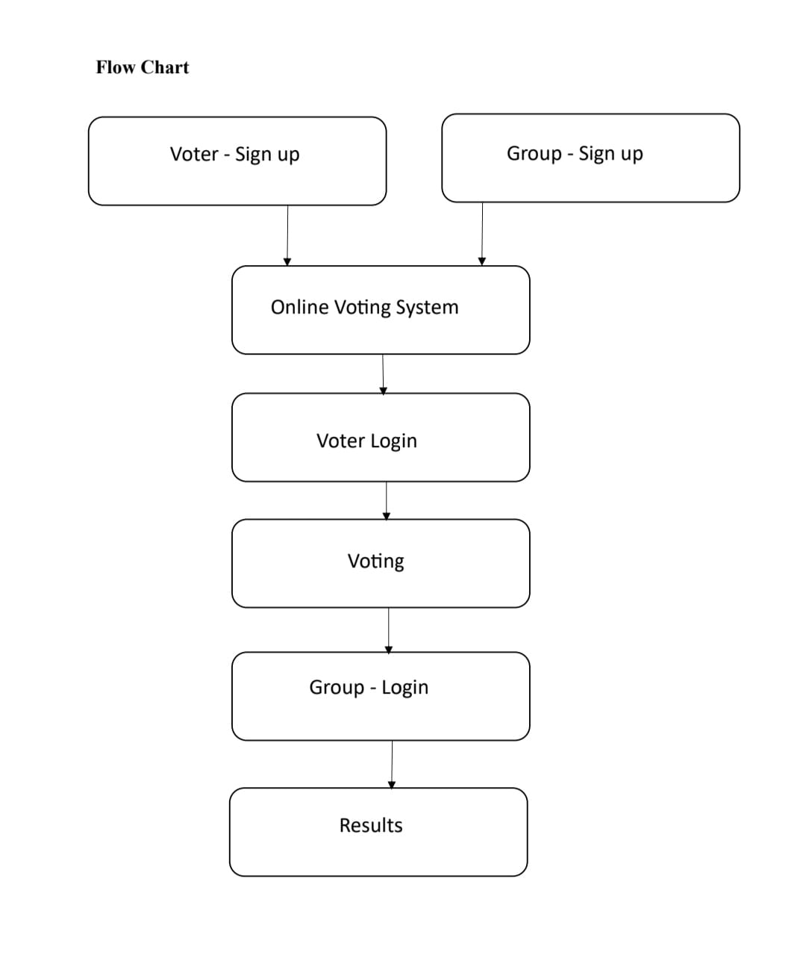



FLOWCHART

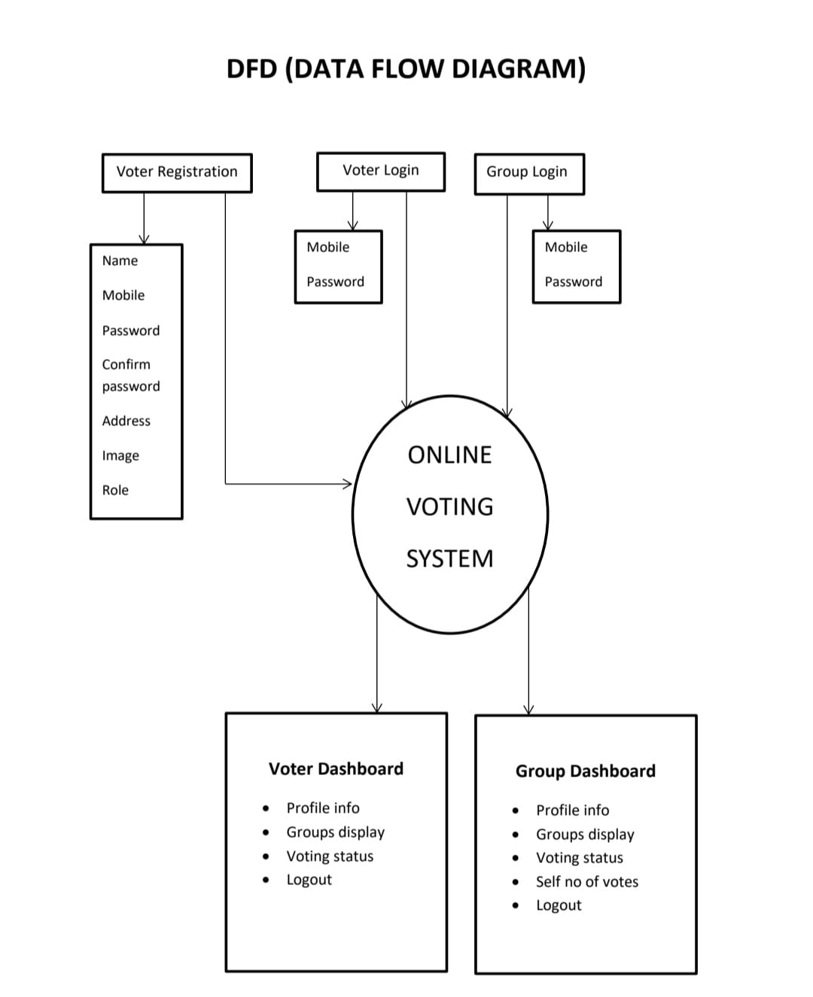

DATA FLOW DIAGRAM

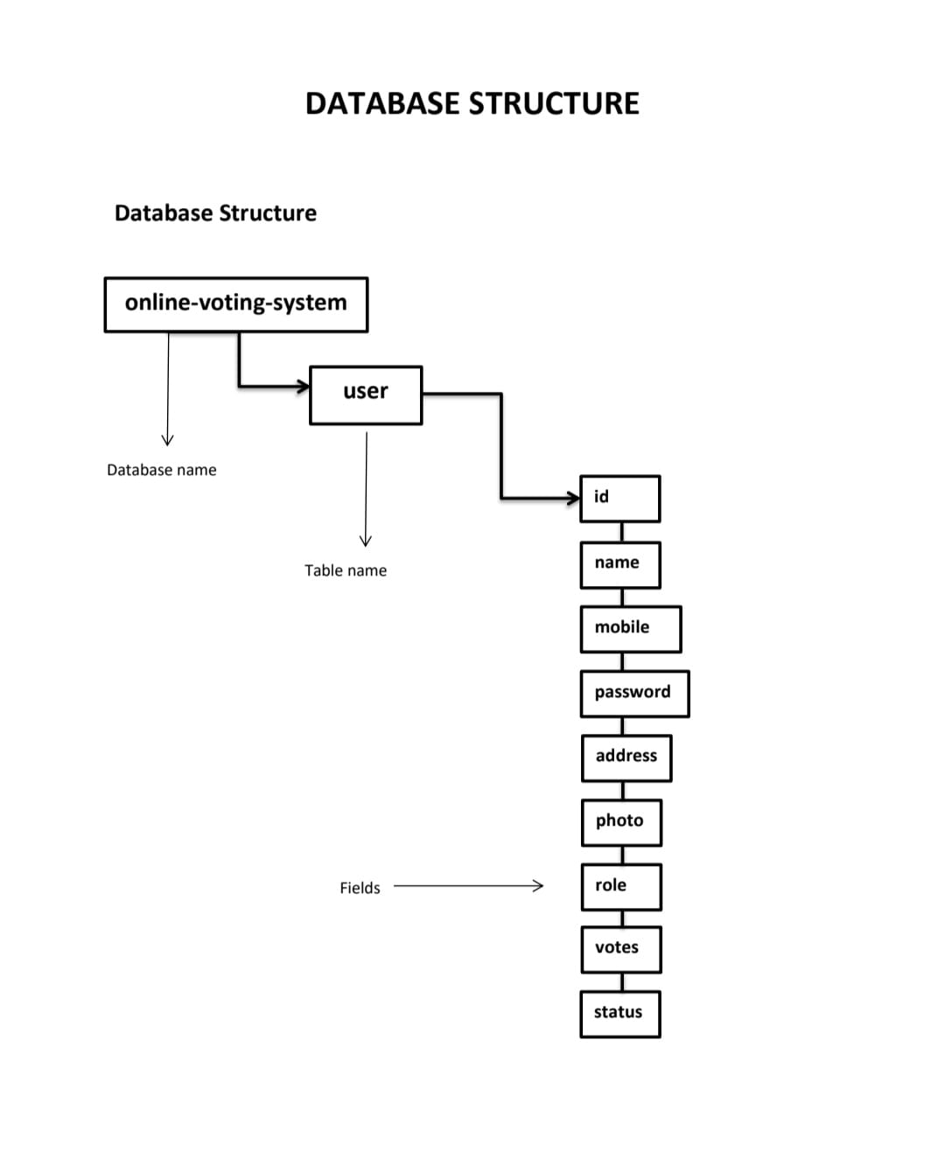

DataBase Schematic Diagram

**5.1.1 Algorithms Used:**

1.Haar Cascades Classified

2.Homographic Encryption Scheme

3.Cryptographic Techingues

**5.2 GUI of Working System**

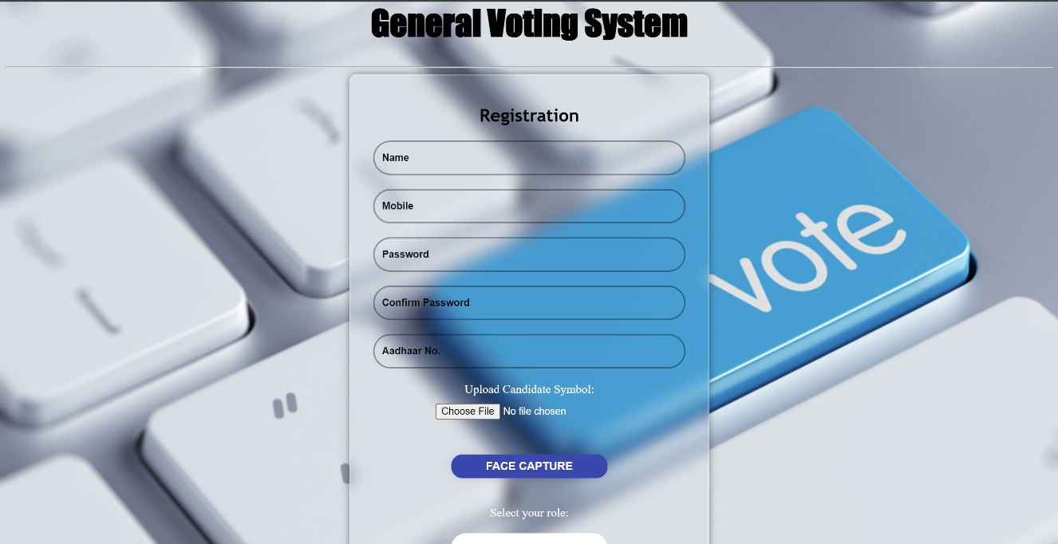

Registration Page

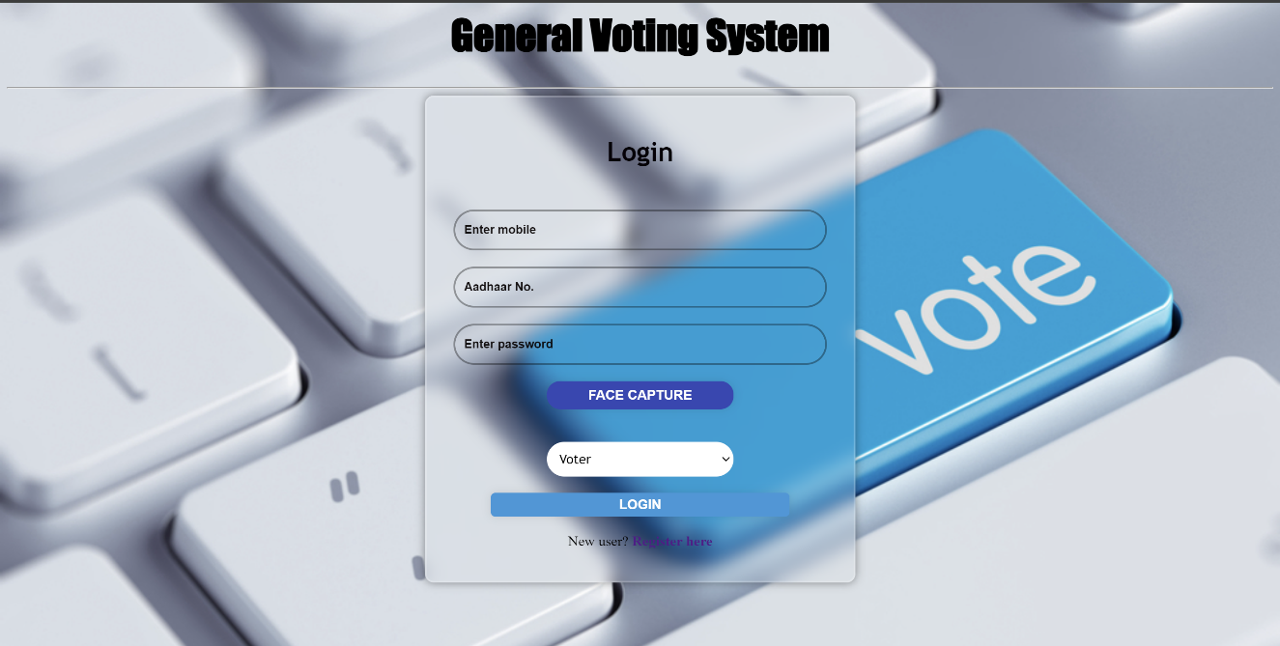

Login Page



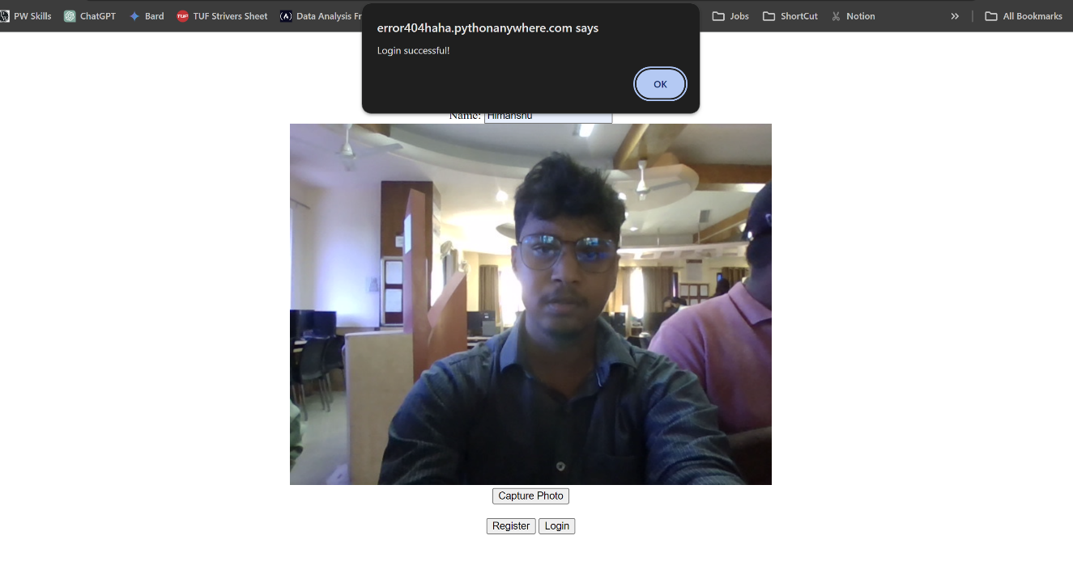

Face Verification

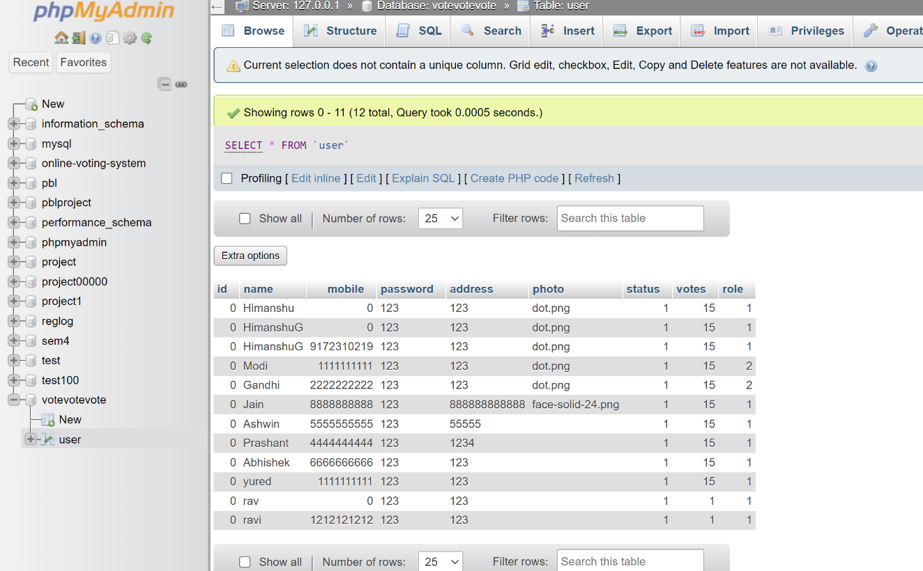

Database

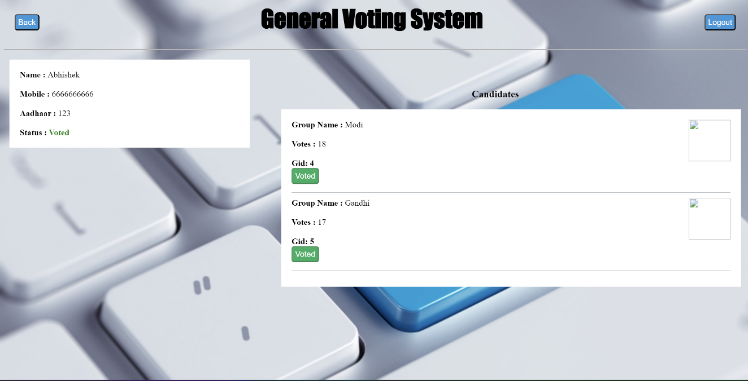

Dashboard

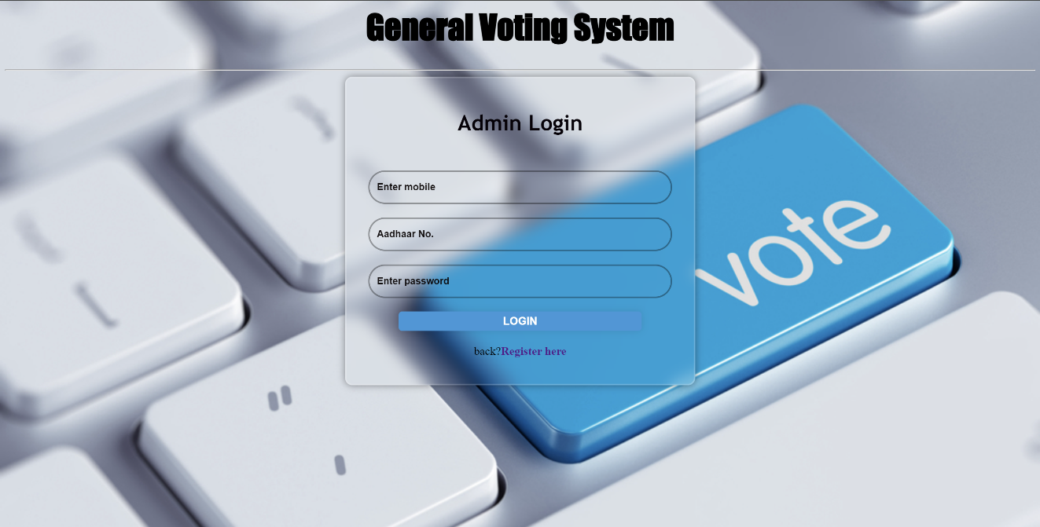

Admin Login Page



Result Page

**Chapter 6**

**Conclusion**

**6.1 Conclusion**

In conclusion, the Voting System is a robust and efficient solution for conducting voting processes over the internet. The system provides various features such as user registration, login, and voting options, and ensures security and data privacy. The development of the system involved extensive research and analysis of existing systems, and the implementation of various software design and development principles.

The project team carried out thorough testing of the system, including various types of testing such as black box testing, data validation test cases, white box testing, and functional validation test cases. The testing was successful, and the system met all the expected standards and requirements.

Overall, the Voting System is a highly useful and innovative solution that can help save time, energy, and cost associated with traditional voting methods. It has the potential to improve the efficiency and transparency of voting processes, making it a valuable tool for governments, organizations, and communities.

**Future Scope**

**6.2 Future Scope**

The Voting System exhibits significant potential for future development and expansion in several areas. Some potential future scope areas are:

1. Integration with blockchain technology to enhance security and transparency in the voting process.

2. Development of a mobile application to provide more flexibility and accessibility to users.

3. Expansion to support multiple languages and internationalization to enable voting across different countries and regions.

4. Integration with biometric authentication technologies to ensure the identity of voters and prevent fraud.

5. Leveraging artificial intelligence and machine learning algorithms to enhance the precision and dependability of the voting procedure.

6. Integration with social media platforms to increase user engagement and participation in the voting process.

7. Development of analytics and reporting features to provide insights and trends on voting patterns and behaviour.

By incorporating these future scope areas, the Online Voting System can continue to evolve and provide a reliable, secure, and efficient platform for conducting voting processes over the internet, while addressing the changing needs and expectations of users.

**References**

1. B. Shrestha and S. Khanal, "Online Voting System," International Journal of Computer Science and Network Security, Volume. 16, Issue 12, Pages 105-112, Year 2016.
2. N. D. Pham and T. T. Nguyen, "Design and implementation of an Online Voting System Based on Blockchain technology," presented at 2018 International Conference on Advanced Computing and Applications (ACOMP) in Ho Chi Minh City, Vietnam, 2018, pp. 86-91.
3. M. A. Alamri, M. S. Khan, M. I. Alghamdi and A. A. Alaskar, "An online voting system utilizing biometric authentication and blockchain technology," presented at the 2019 IEEE 4th International Conference on Cloud Computing and Big Data Analytics (ICCCBDA) in Chengdu, China, 2019, pp. 7-11.

1. S. Kim, H. Choi and S. Park, "Design and Implementation of an Online Voting System for E-government Services," presented at the 2017 14th International Conference on Ubiquitous Robots and Ambient Intelligence (URAI), Jeju, South Korea, with proceedings published in 2017, pp. 352-355.

1. S. J. Gawali and A. N. Gaikwad, "Online Voting System leveraging Artificial Intelligence and Machine Learning," presented at the 2020 International Conference on Computer Science, Engineering and Applications (ICCSEA) in Pune, India,with proceedings published in 2020, pp. 1-4